**Documentations for API endpoints.**

**Test data:**

Rooms data:

{

"numberOfSeats": 10,

"amenities": ["Projector", "Whiteboard", "WiFi"],

"pricePerHour": 500,

"bookings": []

}

{

"numberOfSeats": 20,

"amenities": ["Projector", "Conference Phone", "WiFi"],

"pricePerHour": 1000,

"bookings": []

}

{

"numberOfSeats": 5,

"amenities": ["Whiteboard", "WiFi"],

"pricePerHour": 300,

"bookings": []

}

Bookings:

{

"id": 1,

"customerName": "John Doe",

"date": "2024-08-22",

"startTime": "10:00",

"endTime": "12:00",

"roomId": 1

}

{

"id": 2,

"customerName": "Jane Smith",

"date": "2024-08-22",

"startTime": "14:00",

"endTime": "16:00",

"roomId": 2

}

{

"id": 3,

"customerName": "Alice Johnson",

"date": "2024-08-23",

"startTime": "09:00",

"endTime": "11:00",

"roomId": 3

}

**Creating a room:**

Endpoint: POST http://localhost:3000/rooms

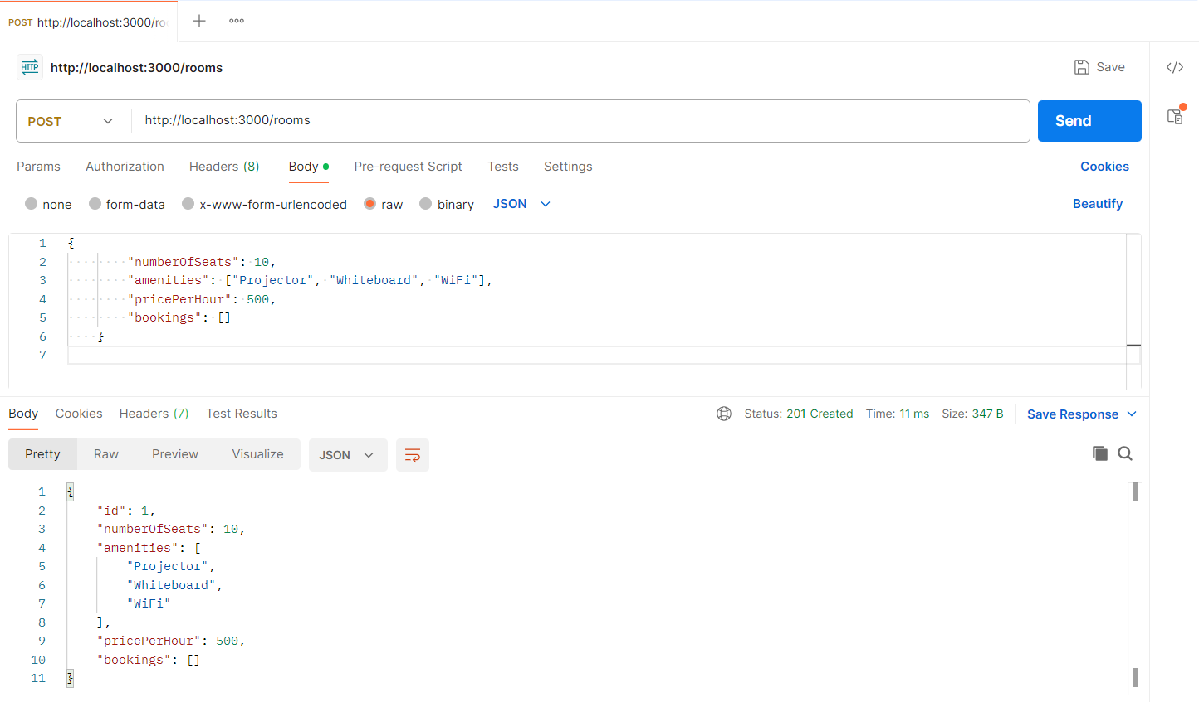

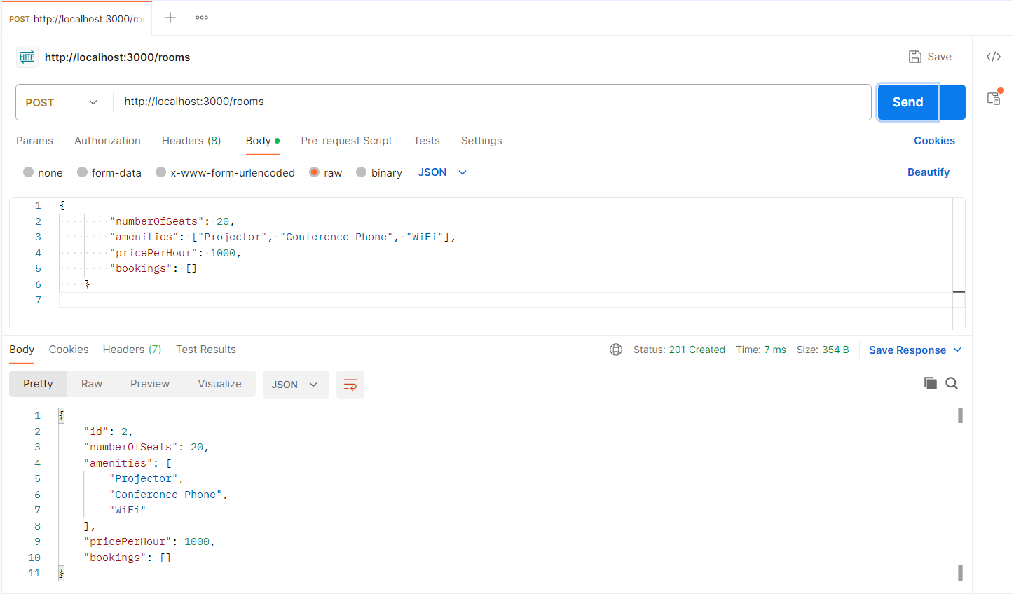

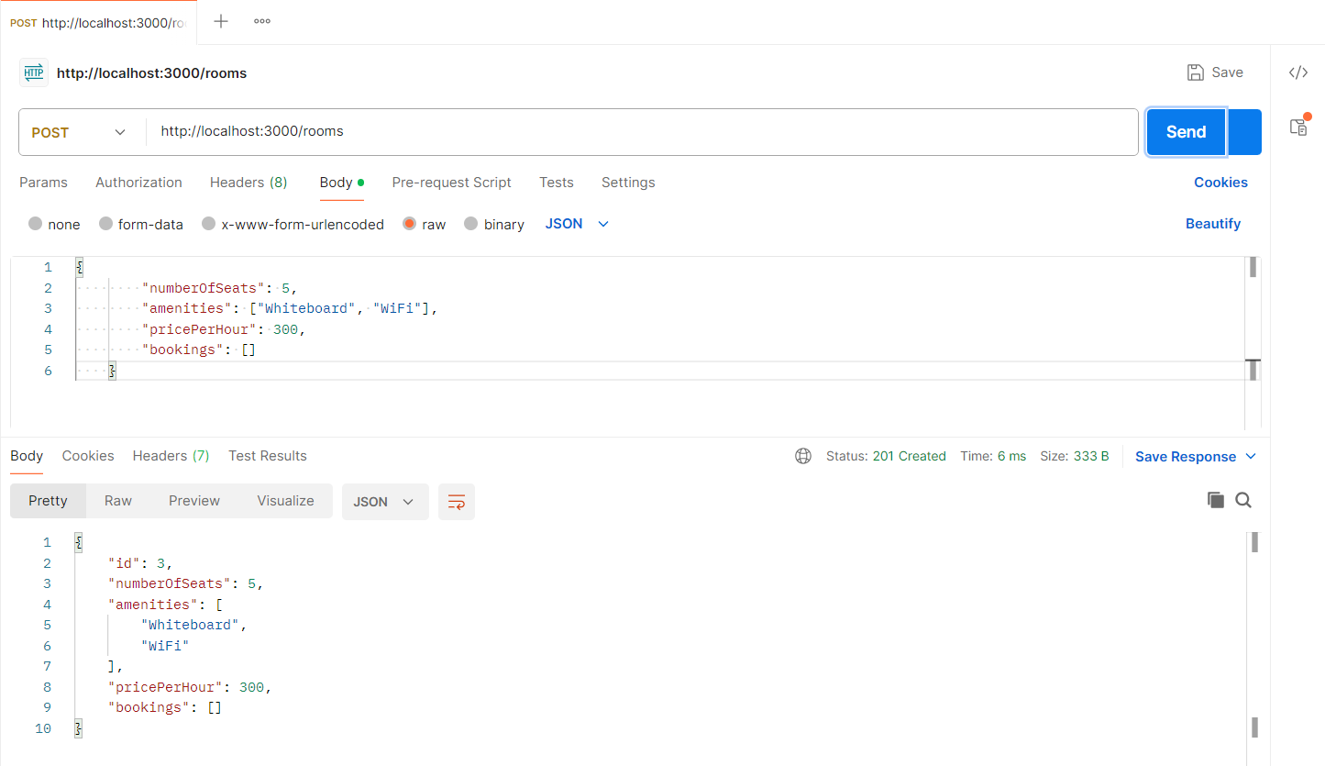

**Creating bookings:**

Endpoints: POST http://localhost:3000/bookings

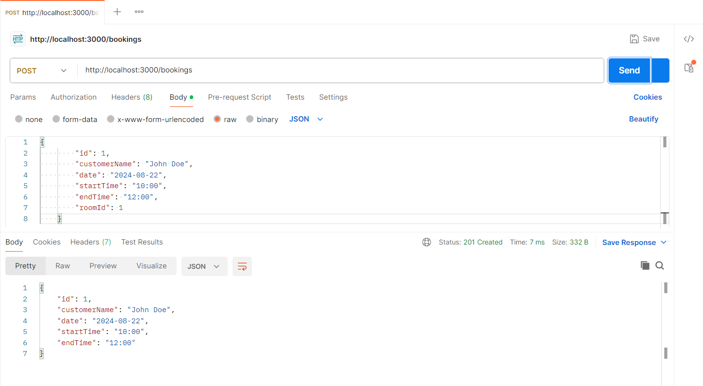

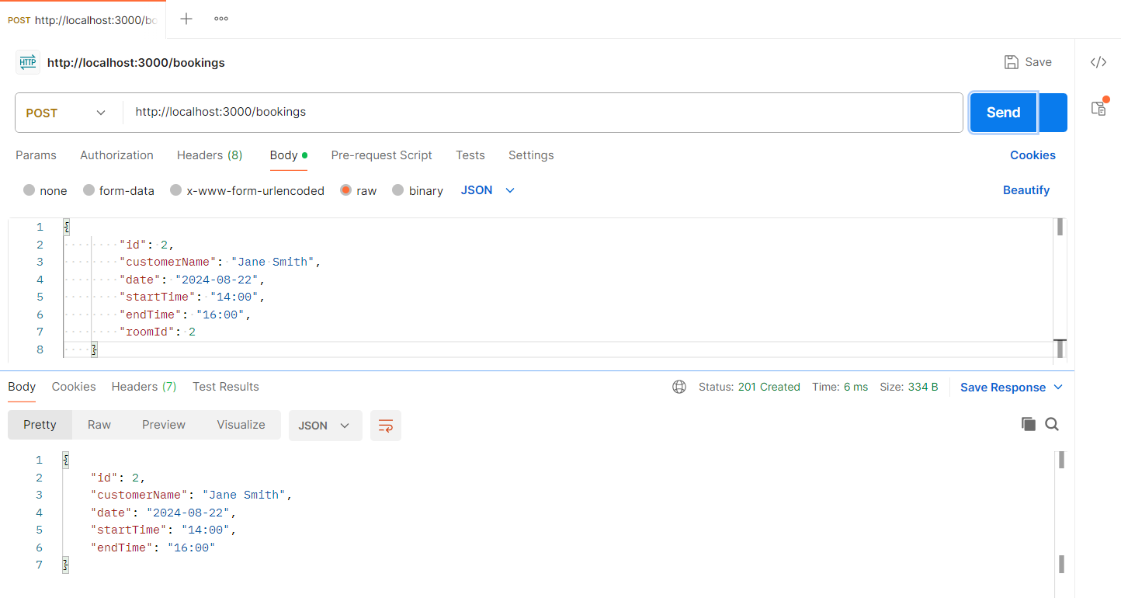

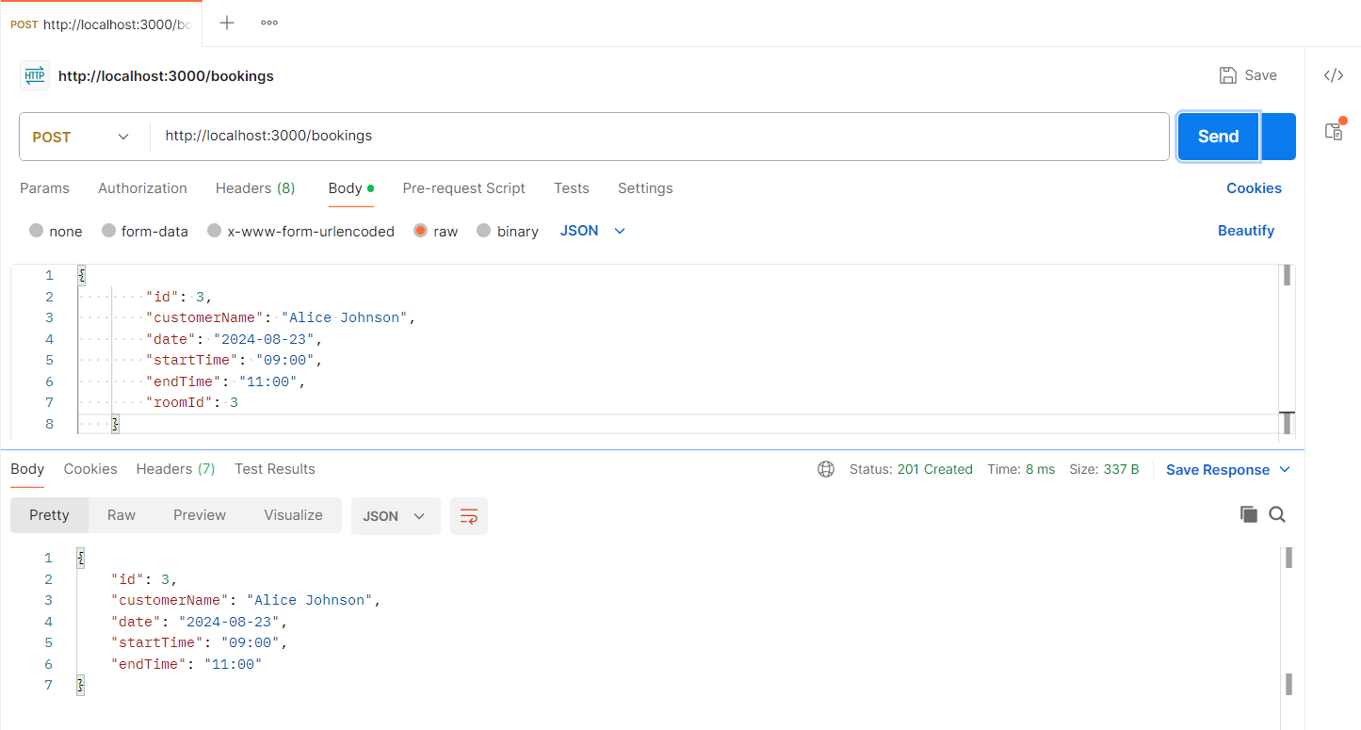

**Throwing error for already booked:**

Endpoints: POST http://localhost:3000/bookings

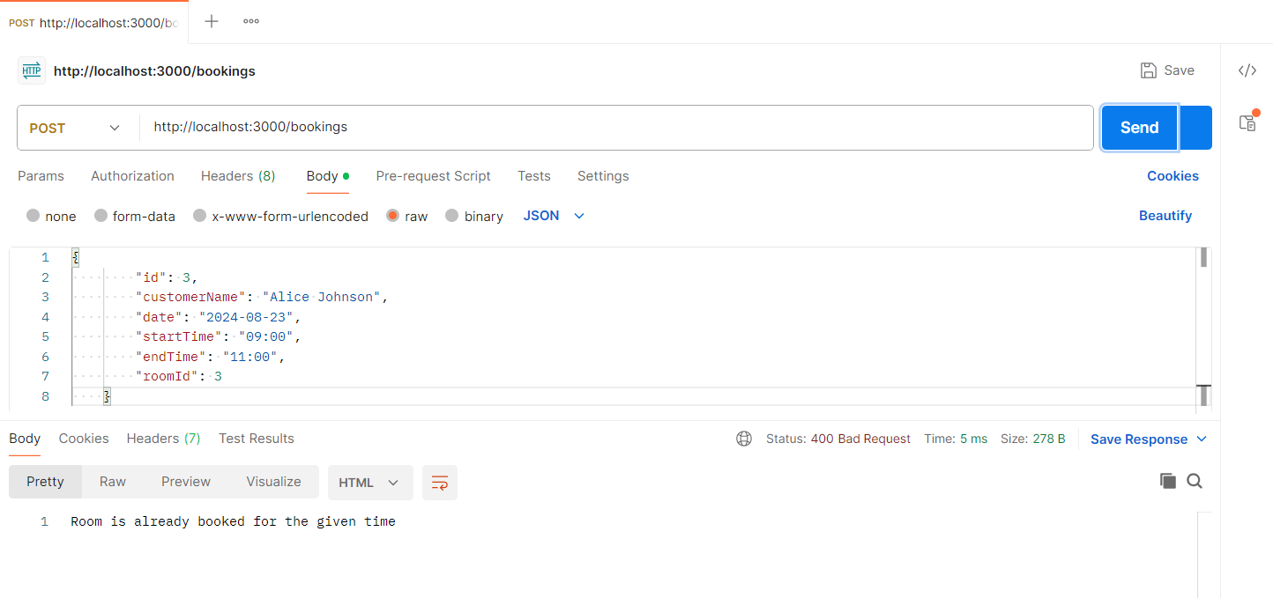

**List all rooms with booked data:**

Endpoint: GET http://localhost:3000/rooms

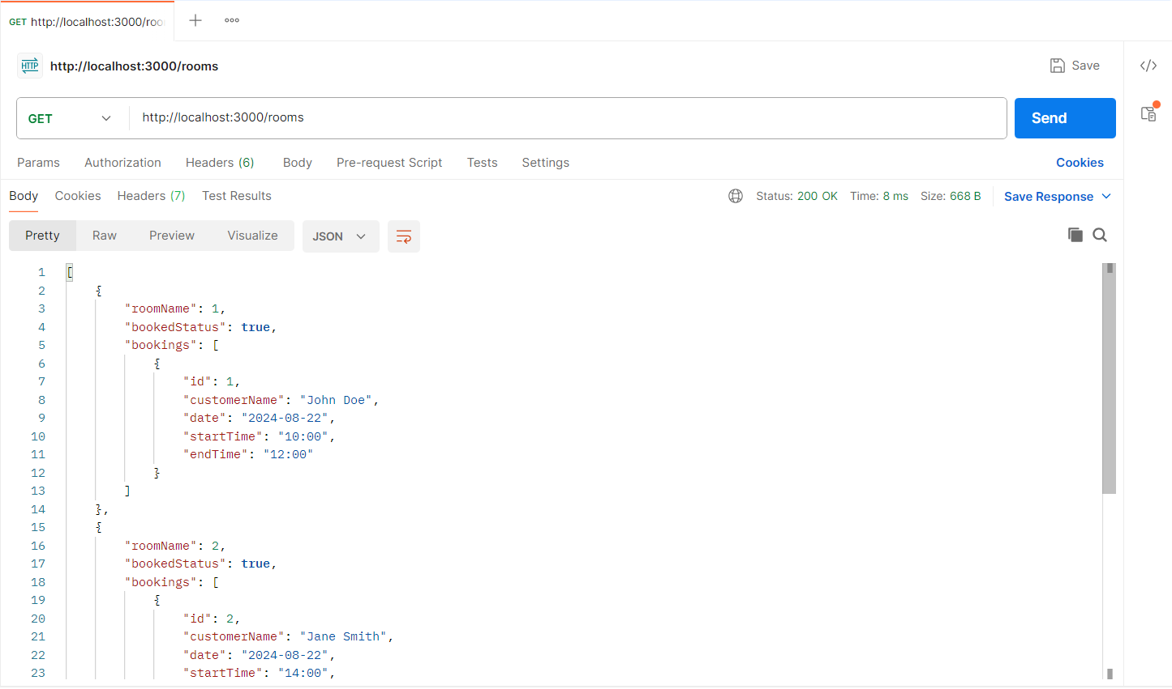

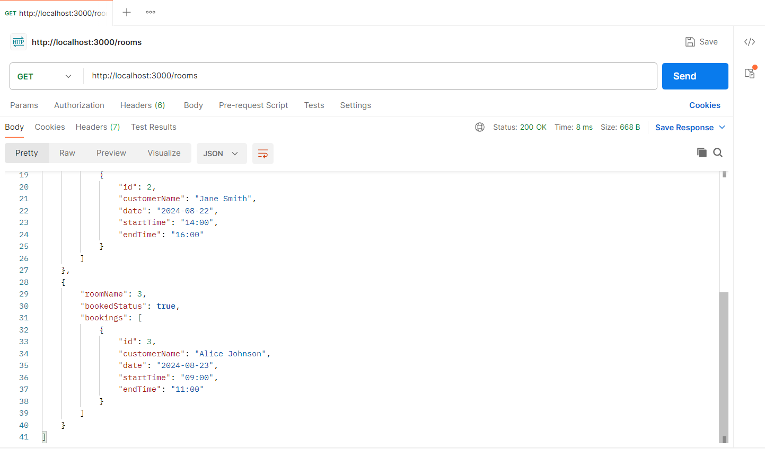

**List all customers details:**

Endpoints: GET http://localhost:3000/customers

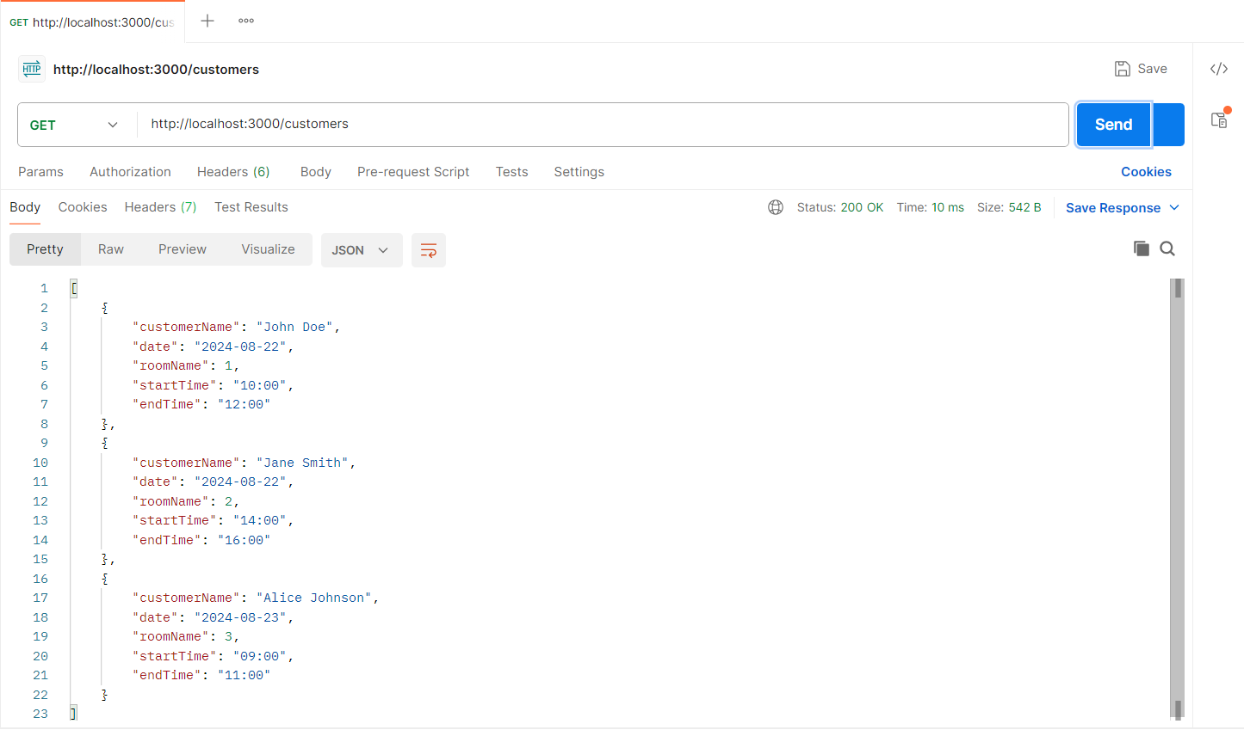

**List number of bookings for specified customer**

Endpoint: GET http://localhost:3000/customers/Jane Smith/bookings

